

ROMANIAN JOURNAL OF PSYCHOLOGICAL STUDIES

HYPERION UNIVERSITY
www.rjps.hyperion.ro

INSTRUCTIONS FOR AUTHORS
ARTICLE TEMPLATE
TITLE 14 TNR UPPER CASES

FIRST NAME, SECOND NAME ª
ª Hyperion University, Faculty of Psychology and Educational Sciences, Department of Psychology

Abstract
This document outlines the main editing instructions and recommendations to be followed by authors submitting papers for publication in RJSP Romanian Journal of Psychological Studies. The abstract should have 150-20 words and will be presented as a single paragraph. The maximum number of key words allowed is 5. Italic 11 TNR.

Keywords: psychological, studies, journal, paper, research. Italic 10 TNR.

1. INTRODUCTION

Text will be written with 12 TNR. Articles must have between 5 and 10 pages, including references. Authors are invited to submit for publication by email, in MS Word format, type. docx, Times New Roman, size 12, line spacing 1,15, indentation 1,27 cm., A4 normal page size (2.54 cm space above, left, right and below). Post chapters written in bold capital letters (bold) character 12, and subsections with simple capitals. All articles must be written in the style of scientific work, having: Theoretical Introduction, objectives and hypotheses, method: participants/subjects, tools/materials/equipment, procedure, experimental design, results, conclusions, acknowledgement, references. The Introduction should provide a clear statement of the problem, the relevant literature on the subject and the proposed approach or solution.

2. OBJECTIVE AND HYPOTHESES

2.1. OBJECTIVE

2.2. HYPOTHESES

3. METHOD

It should include relevant details on the experimental design and techniques so that the experiments can be repeated. However, only truly new procedures should be described in detail; previously published procedures should be cited, and important modifications of published procedures should be mentioned briefly.

4. RESULTS

The Results must be clearly and concisely with the help of appropriate illustrative material tables and/or figures. The discussion should interpret the findings in view of the results obtained in this and in past studies on this topic.
To decide whether to retain or reject the null hypothesis (H0), the results of inferential statistical tests will include the p-value (statistical significance), the 95% confidence interval limits and the effect size.

4.1. TABLES AND FIGURES

Tables, written in 11 TNR, along with explanations (title number), graphs, figures and legends associated will be integrated into written text.
For example:

Table 1. Psychometric characteristics for Rosenberg Questionnaire

Research year | Minimum score | Maximum score | Average | Standard deviation | Median | Alpha Crombach consistency coefficient
1998 (Baban)  N=220 students | 15 | 39 | 27.54 | 4.09 | 27 | 0.740
2013 (Robu)  N=490 teens | 15 | 40 | 31.49 | 4.75 | 32 | 0.790
2018 (Vasiliu)  N=413 general population | 13 | 40 | 29.95 | 5.97 | 30 | 0.836

Table 2. Associations between age, gender and optimism

 | 1. | 2. | 3.
1. Optimism | 1.000
1. Optimism | .
2. Age | .074* | 1.000
2. Age | .041 | .
3. Gender | -.032 | -.201** | 1.000
3. Gender | .461 | .000 | .
*. Correlation is significant at the 0.05 level (2-tailed).
**. Correlation is significant at the 0.01 level (2-tailed).

Tabel 3. Summary of Simple Linear Regression Predicting SUM_SAS-M from SUM_PTSD (N=93)

Variable | B | SE Bootstrap | p-value Bootstrap | 95% BCa CI
SUM_PTSD | -0.514 | 0.166 | 0.002 | [-0.917, -0.168]
(Constant) | 42.471 | 6.264 | <0.001 | [30.245, 55.254]

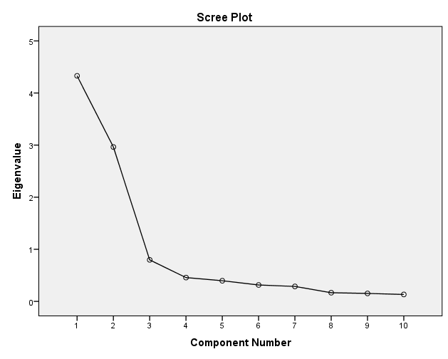
Figure 1. Variation explained through factors

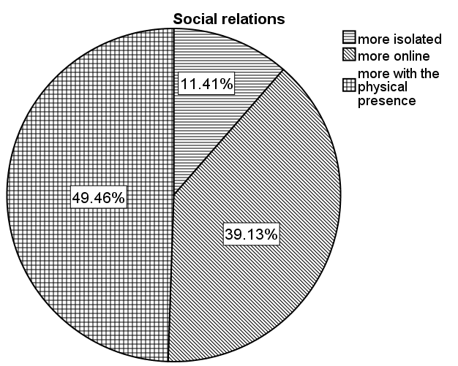

Figure 2. Distributions of social relations modalities adopted in the COVID 19 pandemic

It is desirable that the tables and images to be placed where they are comments about the content of the paper.

5. CONCLUSIONS

The authors of the works submitted for publication, can contact members of the editorial staff and Editorial throughout the reviewing process, to request status information that was manuscript.

ACKNOWLEDGMENT

Here the author should write the grant support or other financing support.

REFERENCES

Bibliography, written in 11 TNR, will be presented at the end of the paper, in alphabetical order, use the APA style citation.

For a book:
1. Author, A. B., & Author, C. D. (2016). Title of book. Location: Publisher.

For a chapter in a book:
1. Author, A. B., & Author, A. B. (2015). Title of chapter. In A. Editor, B. Editor, & C. Editor (Eds.), Title of book (pp. xxx-xxx). Location: Publisher.

Journal article:
1. Author, A. B., & Author, A. B. (2016). Title of article. Title of periodical, volume number (issue number), pp-pp.

Copyright: Submission of a manuscript implies that the work described has not except in the form of an abstract or as part of a published lecture, been published before (or thesis) and it is not under consideration for publication elsewhere; that when the manuscript is accepted for publication, the authors agree to automatic transfer of the copyright to the publisher

