INSTRUCTIONS FOR AUTHORS
ARTICLE TEMPLATE
QUALITATIVE RESEARCH ARTICLE TEMPLATE
TITLE 14 TNR UPPER CASES

FIRST NAME, SECOND NAME ª
ª Hyperion University, Faculty of Psychology and Educational Sciences, Department of Psychology

Abstract
The abstract should be presented as a single paragraph of 150-200 words and written in italic, 11 TNR. It should include the research problem, the qualitative approach, participants or corpus, the data collection method, the analytic strategy, the main themes or categories, and the principal contribution of the study. Avoid statistical reporting, hypothesis-testing language, p-values, and causal claims unless the design explicitly justifies them.

Keywords: qualitative research, thematic analysis, interviews, lived experience, meaning-making. Italic 11 TNR. Maximum 5 keywords.

1. INTRODUCTION

Text will be written in Times New Roman, size 12, line spacing 1.15, first-line indentation 1.27 cm, A4 normal page size, with 2.54 cm margins. Articles must normally have between 5 and 10 pages, including references. Authors are invited to submit manuscripts in MS Word format, .docx. Main sections should be written in bold capital letters, 12 TNR, and subsections in simple capitals, in line with the existing RJPS template style.
The Introduction should provide a clear statement of the research problem, the relevant theoretical and empirical literature, and the rationale for choosing a qualitative approach. The section should explain why the phenomenon requires exploration of meanings, experiences, representations, narratives, practices, interactions, or contextual interpretations rather than statistical estimation alone.
All articles must be written in the style of scientific work and should normally include Introduction, Research Aim and Research Questions, Method, Results/Findings, Discussion, Conclusions, Acknowledgment, References, Declaration on the Use of Artificial Intelligence, and Copyright Statement.

2. RESEARCH AIM AND QUESTIONS

2.1. RESEARCH AIM

State the general aim of the study in a concise and operational form. The aim should indicate the phenomenon, population or context, and qualitative perspective.
Example: This study aims to explore how first-year psychology students describe their academic adjustment during the first semester of university.
2.2. RESEARCH QUESTIONS
Qualitative articles should formulate research questions rather than statistical hypotheses, unless the study uses a mixed-methods design with a justified quantitative component. Questions should be open, exploratory, and aligned with the selected method.
Examples: How do participants describe the main challenges of academic adjustment? What meanings do they attribute to the support received from peers and teachers?

3. METHOD

The Method section should contain enough detail to allow the reader to understand the research process, assess the credibility of the findings, and follow the analytic decisions made by the authors. The organization below is consistent with reporting standards commonly recommended for qualitative research in psychology.

3.1. QUALITATIVE DESIGN

Specify the qualitative design or approach used, such as thematic analysis, interpretative phenomenological analysis, grounded theory, narrative analysis, discourse analysis, content analysis, case study, ethnography, or focus-group research. Briefly justify the choice in relation to the research aim and questions.

3.2. PARTICIPANTS, CORPUS, AND SAMPLING

Describe the participants, documents, observations, or other qualitative material analyzed. Specify inclusion and exclusion criteria, sampling strategy, recruitment procedure, number of participants or sources, relevant demographic or contextual information, and the rationale for sample size. If applicable, explain how data sufficiency, saturation, or information power was considered.

3.3. DATA COLLECTION

Describe the data collection method (individual interview, focus group, observation, field notes, diary, document analysis, open-ended questionnaire, audio/video material, or archival material). Include the interview or observation guide when relevant, the duration and setting of data collection, recording/transcription procedures, and any steps taken to protect confidentiality.

3.4. DATA ANALYSIS

Present the analytic procedure step by step. The description should include familiarization with the material, coding procedure, development and refinement of categories or themes, use of software if applicable, handling of disagreements between coders, and criteria used to retain, merge, or rename codes and themes.

3.5. REFLEXIVITY, RIGOR, AND ETHICAL CONSIDERATIONS

Authors should briefly address reflexivity, including the researcher’s relationship to the topic, relevant assumptions, and steps taken to reduce unexamined bias. Depending on the design, the manuscript may report credibility strategies such as audit trail, peer debriefing, member reflection/member checking, triangulation, thick description, negative-case analysis, or transparent coding examples. Ethical approval, informed consent, anonymity, and data protection procedures should be specified.

4. RESULTS / FINDINGS

The Results or Findings section should present the analytic output clearly and concisely. In qualitative research, findings are usually organized by themes, categories, narratives, cases, or interpretative claims. Each theme should be defined, linked to the research questions, and supported by carefully selected illustrative excerpts from the data.
Do not report inferential statistics, p-values, confidence intervals, or effect sizes unless the article explicitly includes a quantitative component. When excerpts are used, identify participants or sources through anonymized labels, for example P01, Interview 3, Focus Group 2, or Document A. Longer quotations should be formatted distinctly and used sparingly.
Tables, written in 11 TNR, along with explanations, titles, figures, diagrams, and legends, should be integrated into the written text at the point where they are interpreted.
For example:
Table 1. Example of qualitative coding structure
Research question | Theme | Subtheme / code | Illustrative excerpt
How do participants describe academic adjustment? | Negotiating autonomy | Managing time independently | "I had to learn how to organize myself without someone reminding me every day." (P04)
How do participants describe academic adjustment? | Seeking relational support | Peer reassurance | "It helped to see that others were confused too, because I felt less alone." (P09)
How do participants describe academic adjustment? | Redefining competence | From performance to learning | "At first I wanted only high grades; later I understood that learning mattered more." (P12)

Table 2. Example of theme presentation in the Results section
Theme | Brief definition | Evidence in the material
Theme 1. Uncertainty at transition | Participants describe the beginning of university as a period of ambiguity and role redefinition. | Repeated references to confusion, comparison with colleagues, and fear of not meeting academic expectations.
Theme 2. Support as normalization | Support is experienced less as direct problem solving and more as confirmation that difficulties are shared. | Peer conversations, informal mentoring, and teacher availability are described as reducing isolation.
Theme 3. Autonomy as learned practice | Autonomy appears gradually, through everyday planning, failure, correction, and reflection. | Participants report changes in time management, study routines, and help-seeking behavior.

Figures may include conceptual maps, coding trees, thematic diagrams, or process models, if they clarify the interpretation and are discussed in the text. The thematic relations are illustrated in Figure 1 and the transition process is summarized in Figure 2.

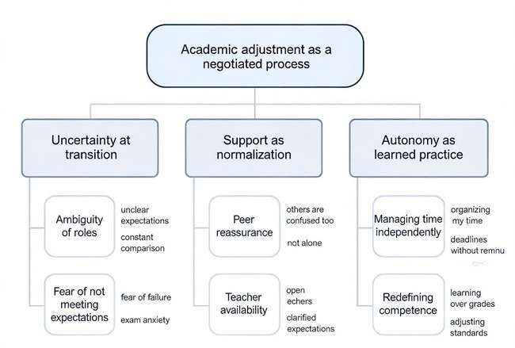

Figure 1. Example of a thematic map or coding tree for academic adjustment
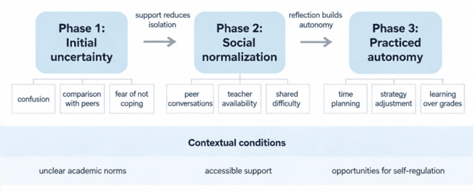
Figure 2. Example of a process model generated from qualitative findings on academic adjustment

5. DISCUSSION

The Discussion should interpret the findings in relation to the research questions, theoretical framework, and previous studies. Authors should explain what the themes, categories, or narratives reveal about the phenomenon and how the qualitative evidence supports these interpretations. Avoid causal claims unless the design and evidence justify them. The section should include the contribution of the study, practical or theoretical implications, limitations, and directions for future research. Limitations may refer to sampling, context, researcher positionality, transferability, available data, or analytic scope.

6. CONCLUSIONS

The Conclusions section should briefly synthesize the central findings and their relevance. It should not introduce new data or unsupported generalizations. The authors of works submitted for publication may contact the editorial staff throughout the reviewing process to request information about manuscript status.

ACKNOWLEDGMENT

Here the author should state grant support, institutional support, or other financial support. If there is no funding, this may be stated explicitly.

REFERENCES

Bibliography, written in 11 TNR, will be presented at the end of the paper in alphabetical order, using APA style citation. For qualitative manuscripts, authors are encouraged to include methodological references relevant to the chosen approach, such as APA JARS–Qual, COREQ, thematic analysis, grounded theory, or phenomenological analysis references, where applicable.
For a book:
Author, A. B., & Author, C. D. (2016). Title of book. Location: Publisher.

For a chapter in a book:
Author, A. B., & Author, C. D. (2015). Title of chapter. In A. Editor, B. Editor, & C. Editor (Eds.), Title of book (pp. xxx-xxx). Location: Publisher.

Journal article:
Author, A. B., & Author, C. D. (2016). Title of article. Title of Periodical, volume(issue), pp-pp. https://doi.org/xxxxx

Declaration on the use of Artificial Intelligence:
☐ I did not use generative artificial intelligence tools for the research, data analysis, interpretation of results, or formulation of conclusions.
☐ I used generative artificial intelligence tools exclusively for linguistic support, stylistic reformulation, and improving the clarity of the text, without delegating the generation of scientific content, data analysis, interpretation of results, or formulation of conclusions. The author assumes full responsibility for the accuracy, originality, integrity, and scientific content of the article.

Copyright: Submission of a manuscript implies that the work described has not, except in the form of an abstract or as part of a published lecture or thesis, been published before and is not under consideration for publication elsewhere; when the manuscript is accepted for publication, the authors agree to the transfer of copyright to the publisher.

